BeachLIFE Fitness
Children’s Schedule
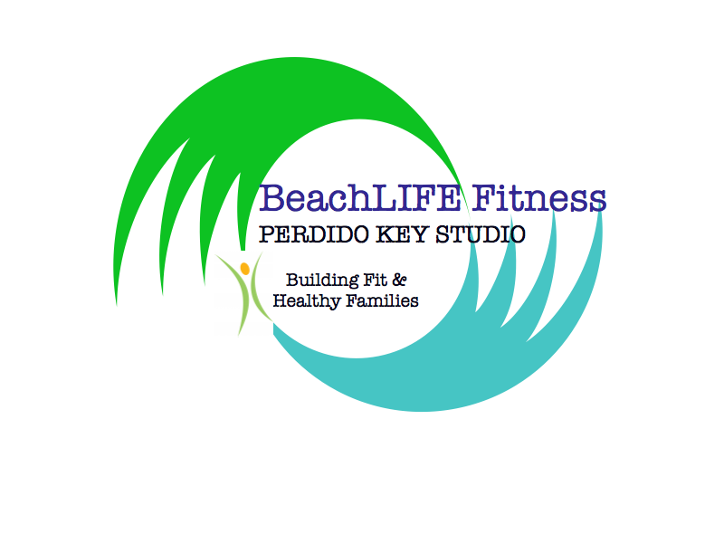
2019-2020

(509)220-6066
beachlifefit@gmail.com
beachlifefitness.com
Child Rates
Tuition Per Month Aug-May
One Class Per Week
Parent Child Gymnastics: $45
Tiny Ballerinas: $45
Preschool Gymnastics: $52
Beginner Gymnastics/Ballet: $55
Intermediate Gymnastics 90min: $78
Open Gym: $5 Drop in / $25 for 6
Sibling and Multi Class Rates Available

No Membership / Fees Recreational Children’s Programs for your 0-13year old
Enrollment Required - Contact us today!!
13118 Sorrento Road Suite D
Follow us on Facebook & Instagram

Monday | Tuesday | Wednesday | Thursday | Friday | Saturday
10:30-11:15am  Mom & Me Gymnastics |  | 10:30-11:05am TINY  BALLERINAS  (2-3YRS) | 10:30-11:15am  PRESCHOOL  (3-4YRS)  Gymnastics | 10:30-11:30am Toddler Open Gym (under 5)
3:45-4:45pm  Beginner  (4/5 YRS) Gymnastics | 4:00-4:45pm  PRESCHOOL  (3-4YRS)  Gymnastics | 3:45-4:45pm Ballet Beginner  (4-7YRS) | 3:45-4:45pm  Beginner  (5-7 YRS)  Gymnastics | 2:30-6:00pm PRIVATE LESSONS - Intermediate / Advanced Gymnastics
5-6pm  Beginner (5-7YRS)  Gymnastics | 5 pm Boys Gymnastics (5-8YRS) | 5:00-6:00 Beg/Intermediate Ballet (8+YRS) | 5pm-6:30pm  Intermed/Adv Gymnastics
6pm-7:30pm  Intermed/Adv Gymnastics | 6pm-7:30pm  Intermed/Adv Gymnastics

BeachLIFE Class Descriptions ~ Fitness For The WHOLE Family!

Ballet: Learn the fundamentals of this classic. Children ages 2-13 are welcome in our age group specific classes. Skills will be taught, little bodies will learn proper form, technique and a love for dance. Age appropriate learning games and techniques will be used to create delight in your little ballerina as she dances through the studio and then on to the stage in our Spring Recital.

Barre: Tone, strengthen, lengthen and balance in this ballet inspired adult fitness class is a fabulous combination of dance, yoga and Pilates. No skill or experience required!

Boot Camp: This high energy workout will challenge every body type. Intervals, Circuit, HIIT, Calisthenics, and much more are used to give you 60 minutes of exciting, calorie-blasting strength and cardio! Each workout is uniquely designed by our team of trainers & tailored to your needs!

Boys Gymnastics: Let you little man learn to love fitness, tumbling and gymnastics through this energetic fitness class! Boys age 5-9 will tumble, climb, jump, condition, swing and build total body strength in 60 minutes of this male gymnastics inspired class.

Forever Fit ~ Senior Fitness: This 45 minute class is great for our active agers! This low impact class will provide strength, balance, flexibility and energy for everyday life and more!

Gymnastics: Create a love for tumbling and gymnastics through our recreational program. Children will learn tumbling skill, beam, bars and floor routines. This high energy class is available for children 2-9 years of age.

Junior Boot Camp: This exciting class is great for your child (ages 10+). Our top certified trainers teach the fundamentals of fitness, weight lifting, body conditioning, sport training, healthy living, and more! Each week your child will have a dedicated lesson to build on during the upcoming classes, goal setting and progress will be encouraged! This is a fantastic way for your child to learn proper (age appropriate) form, technique and skill that will set him or her up for lifetime of fitness!

Mom and Me Gymnastics: Take your toddler on a fitness journey. They will learn gymnastics skill through this fun, interactive 45 minute class. Parent is an active participant in this high energy tumbling, balancing, jumping, climbing, swinging class!!

Suspension Training: TRX inspired workout with our Suspension Straps. You will tone, strengthen, lengthen and work your entire body with this controlled bodyweight workout. Cardio blasts are added to your class to burn calories all while you train.

Toddler Open Gym: 60 minutes of active play for your toddler. Mom and Me fun with our creative movement, tumbling and fitness equipment. A great play-group outing!! Drop in rates and punch cards available.

Yoga for Fitness: This 60 minute class will transform your mind and body. Take yourself on a body strengthening, stretching and balancing experience, through a variety of traditional yoga poses and flows in a fitness style class. This form of Hatha Yoga will invigorate your body.

